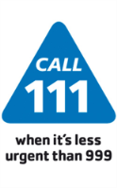

Setting up your GP Practice to

receive NHS 111 Messages directly into SystmOne

*Last updated 25/09/2015*

Introduction

* This is a guide to explain how practices can now receive NHS 111 messages directly into SystmOne via the latest messaging system called **ITK** (Interoperability Toolkit) which EMIS Web, SystmOne and Vision can handle.
* Even if you think you are already receiving NHS 111 reports directly, please **do not** ignore this guide as you may currently be receiving only some rather than all of your patient’s 111 reports and this might not be by best method via ITK. Often it has been incorrectly assumed that if you are receiving GP Out of Hours reports then you are automatically receiving all NHS 111 reports too. Your patients’ calls to NHS 111 might be handled by any NHS 111 provider across the country but currently you might only be receiving reports if your local 111 provider took the call (which cannot be guaranteed). The move to receive messages via ITK should address this issue.
* If you are on **SystmOne**, this guide provides step by step instructions on how to set up your practice to receive NHS 111 reports. **It will take less than a minute to do** and should help reduce the workload for your staff and improve the experience for both patients and staff. If you have been receiving 111 messages by NHSmail, this should end once you have completed the quick steps in this guide.

If you have any problems, please contact your Directory of Services (DOS) lead directly at:

|  |  |  |
| --- | --- | --- |
|  | (DOS Lead) - @nhs.net |  |

|  |
| --- |
| **IMPORTANT**:   * If you randomly obtained this guide, then the instructions might not work if your local DOS team have not carried out some steps (in the “Directory of Services” – explained later) to set up your practice for ITK messaging. * You are advised to contact your local DOS team for further assistance. If your local DOS team needs assistance, then they can contact the author of this guide:   Dr Shanker Vijayadeva (GP) - [svijayadeva@nhs.net](mailto:svijayadeva@nhs.net) |

Section A: For SystmOne Practices

Step 1 - Access “Organisation Preferences”

You need to be an user with the rights to access and adjust “Organisation Preferences” which can be found as shown below:

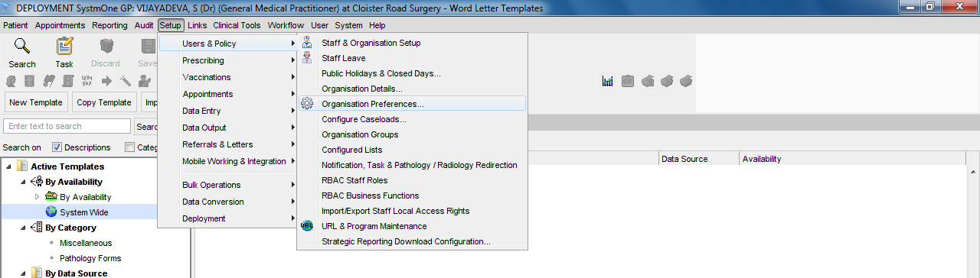

**Select “Setup” 🡪 “Users & Policy” 🡪 “Organisation Preferences”**

Step 2 – Select and Expand “NHS 111”

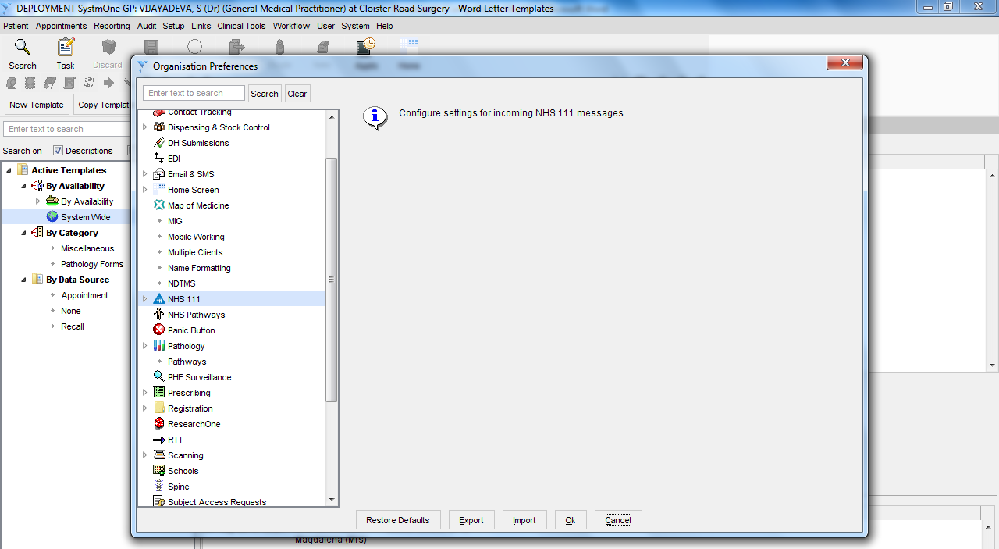

1. **Scroll list and find “NHS 111”**
2. **Now click the arrow on the left of “NHS 111” to expand this option to set it up**

Step 3 – Setting up “PRIMARY Messages”

**PRIMARY** messages are NHS 111 reports/messages generated when a patient has called NHS 111 and been **referred to your practice** for further review/action (and usually NHS 111 has specified within what timeframe this is required).

**(3) Click on “+” to add the “Dos Service ID” for your practice (see Appendix) which is covered in Step 4**

**(2) Tick the box to enable incoming 111 Primary messages to be received**

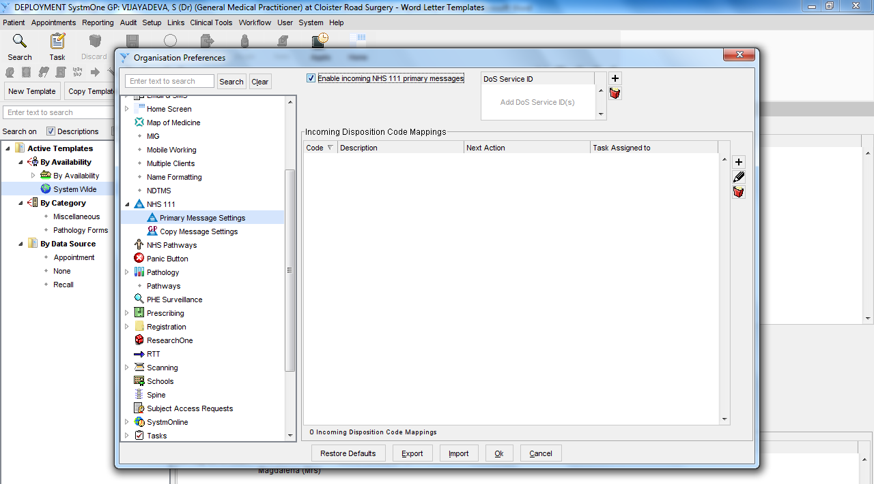

1. **Select “Primary Message Settings”**

Step 4 – Enter your practice’s “DOS Service ID”

You can find your practice’s **DOS SERVICE ID** in the **Appendix** at the end of this guide.

DOS stands for the “Directory of Services” which is used by NHS 111 to select the best service to refer the patient to (if required) to meet the patient’s needs.

You can also access the Directory of Services at [www.pathwaysdos.nhs.uk](http://www.pathwaysdos.nhs.uk)

Click on “Request a New Account” to request login access. Please be prepared that it can take some time for your request to be approved.

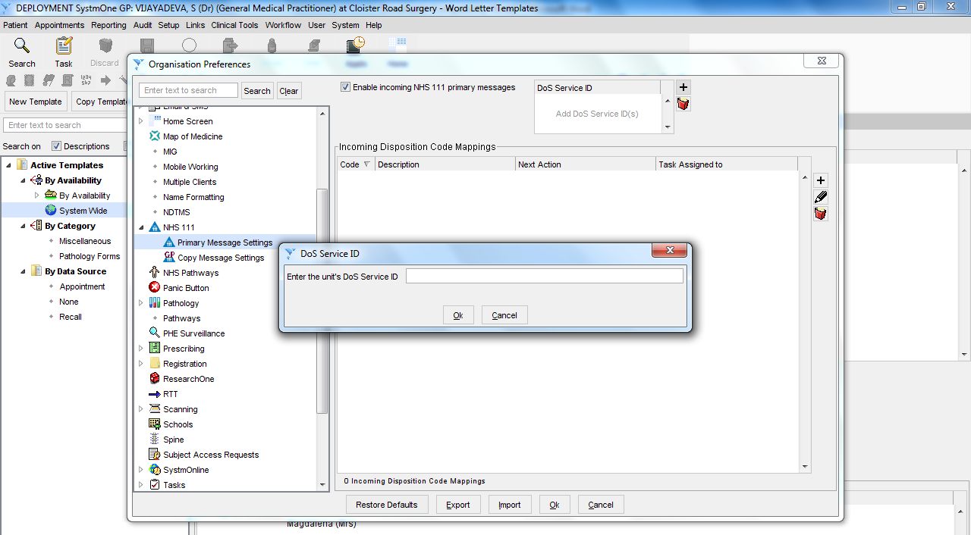

1. **Find your**

**practice’s “DOS SERVICE ID” in the Appendix of this guide**

**(2) Enter your**

**Service ID and**

**click ok**

Step 5 – Setting up “COPY Messages”

**COPY** messages are NHS 111 reports/messages where the patient has called NHS 111 and been referred to services other than your practice and your practice is being copied in mainly for information (and not usually for any action). When you receive a Copy Message, NHS 111 should also be sending a Primary message (for the same patient) direct to the service that the patient is being referred to.

There is one important exception – if your patient has been referred to the GP Out of Hours service, you will normally NOT get a NHS 111 report and should only receive a report from the GP Out of Hours service after they have reviewed the patient (this was a decision made nationally to help reduce excessive, partly duplicating reports received by GP Practices).

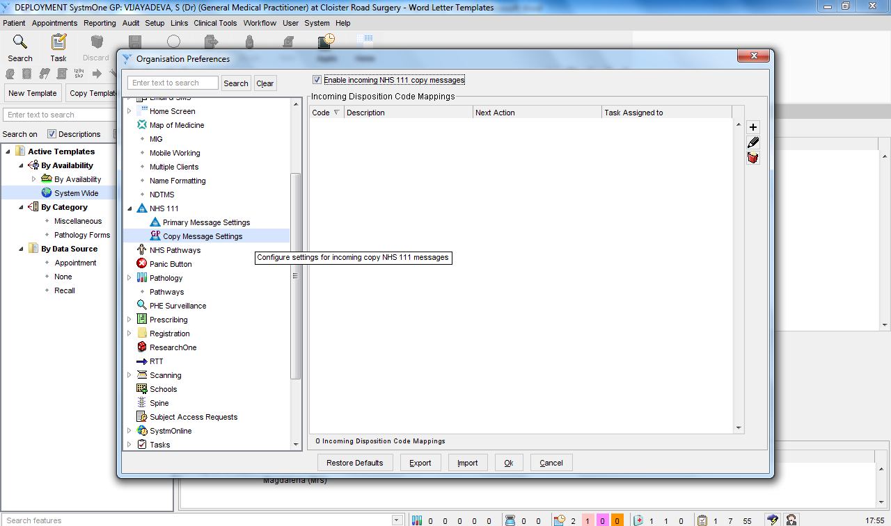

1. **Tick to enable receipt of**

**“NHS 111 copy messages”**

1. **Select “Copy Message Settings”**

There may be rare occasions when you receive BOTH a Primary and Copy message for the same encounter with 111 - e.g. GP weekend opening schemes if your practice also happened to be open for your locality/network. If this occurs, it is due to some limitations in the functionality within the “Directory of Services” (DOS) used by 111.

Step 6 – Finished!

You should now receive 111 Primary and Copy messages via ITK which will arrive as Tasks (usually unassigned) to be managed by your practice.

Keep a look out for these Unassigned Tasks.

Optional Step – Bit Complex!

Each 111 message contains a “Disposition code”. This suggests what course of action might be required within what timeframe for each patient assessed by NHS 111 – one example of a disposition code is “to be seen by a GP within 12 hours”.

**Click “+” to set up a new mapping for a disposition code**

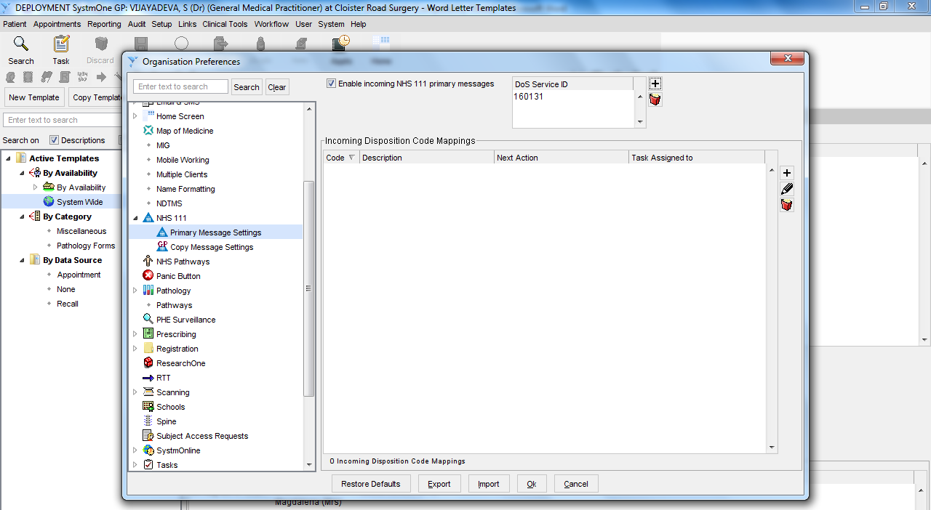

For both Primary and Copy messages, you can “map” different disposition codes to different actions to determine how SystmOne manages the tasks.

For example, you might wish to map some dispositions for Copy messages to file directly into the Patient’s notes (as the patient has been referred to another organisation) but still get a Task to alert you.

You can obtain more information from reading the SystmOne manual/guide titled “**Receiving 111 CDA Messages into GP**”.

It is a bit complex to explain what the different disposition codes mean, so you might wish to wait to see if a further guide is produced to assist you.

Contingency NHSmail address for SystmOne Practices

You will normally be receiving 111 messages via NHSmail (see Appendix for the NHS email address being used for your practice) **until** you follow the steps in this guide to enable 111 messages to be received directly into SystmOne.

Once you have set this up, you will automatically no longer receive reports via NHSmail (you do not need to inform anyone or do anything else for this to happen). Your NHSmail address is still set up as a contingency method to send 111 messages if ever the ITK message fails to be sent/received directly into your practice’s SystmOne. If your practice uses Docman, you may wish to use a NHSmail address connected with your Docman (see Section B for more guidance on setting this up).

**Please check the Appendix for the NHSmail address being used for your practice** (if we have it) and please let your DOS team know (contact details of front page of this guide) if it is missing or requires amending. If you do not have a generic NHSmail account for your practice, you may wish to discuss with your IT Support Helpdesk whether one can be set up for your practice (and develop a process within your practice to ensure it is regularly monitored/checked).

In the longer term, you may also wish to obtain access to [www.pathwaysdos.nhs.uk](http://www.pathwaysdos.nhs.uk) so that you can check and update your practice’s profile when required. Click on “Request a New Account” to request login access. Please be prepared that it can take some time for your request to be approved.

Please now go to Section B to review answers to Frequently Asked Questions.

Section B: Frequently Asked Questions

*Last updated 25/09/2015*

|  |  |  |  |
| --- | --- | --- | --- |
| Q | | **Do I need to contact our GP OOH / 111 provider to sort out how we receive 111 messages for our practice?** | |
| A | | No. NHS 111 uses one centralised “Directory of Services” (DOS) which is part of the software (NHS Pathways) used by NHS 111 providers across the country during calls to assess the patient and find the most appropriate service for the patient’s needs.  The DOS stores the messaging settings for your practice. This process is led by commissioners rather than 111 providers, so even if you did contact your local 111 provider, they are unlikely to be able to alter the messaging settings for your practice.  For GP Out of Hours (GP OOH) reports (often called “Post Event Messages”), please continue to contact your GP OOH provider if you need to alter how you receive these GP OOH messages. | |
| Q | | **What exactly is this new “ITK” messaging?** | |
| A | | It stands for “Interoperability Toolkit” and is a new method of messaging introduced across the NHS which has improvements over previous methods such as DTS (Data Transfer Service). It is quicker to receive/handle messages; it offers more functionality on how documents/reports are presented and it also provides confirmation to the sender that the message was delivered, which reduces the change of messages being lost. You can obtain more information about ITK by visiting this link: <http://systems.hscic.gov.uk/interop/background/itk/faqs>  EMIS Web, SystmOne and Vision can receive 111 messages by this new ITK standard. | |
| Q | | **This is a great guide for Practices on SystmOne, but how do you set up ITK messaging for practices on other clinical systems (e.g. Microtest)?** | |
| A | | Currently only EMIS Web, SystmOne and Vision can handle ITK messagingm although other clinical systems (e.g. Microtest) should follow in the future. If you require information for EMIS Web or Vision, please contact the DOS lead (details on front page) | |
| Q | | **Can I receive 111 messages for my practice by Fax, Post or DTS?** | |
| A | | No. The Directory of Services does not allow 111 messages to be sent by Fax, Post or DTS as these methods are not deemed reliable or robust enough. This is a national decision which cannot be overridden at a local level.  However it may be possible for your local 111 provider to send 111 messages via DTS direct to your clinical system as a local “workaround” solution, but this would not cover calls for your patients handled by other 111 providers across the country. So if your IT system cannot accept ITK messaging, then the most reliable way to receive 111 messages is via NHS email. | |
| Q | | **Can I access the “Directory of Services”?** | |
| A | | If you wish to explore the DOS further, you can access it at [www.pathwaysdos.nhs.uk](http://www.pathwaysdos.nhs.uk)  Click on “Request a New Account” to request login access. Please be prepared that it can take some time for your request to be approved. | |
| Q | | **I am fed up with all these long 111 reports with information with limited value for me as a GP – it is wasting my time! Who can I speak to about this?** | |
| A | | There has been significant feedback from all over the country that much of the information in the 111 message does not offer much value to General Practice. The content/style of the 111 reports is under regular national review to maximise the benefit and relevance for General Practice.  You may wish to raise your views with your local CCG lead for NHS 111, who in turn could raise the points with the National Medical Director for NHS 111.  Please remember that Primary messages are messages that relate to patients who need action/review by your practice as the patient has usually been referred to you for further management. Copy messages usually do not require any action from the GP (as the patient has been referred to another service) and are more for information. | |
| Q | | **Can we receive 111 messages via ITK for our other branch practices/sites/**  **GP Choice service or other services (e.g. weekend service to cover group of practices)?** | |
| A | | If you are on SystmOne, this should be possible and at Step 3, you can simply keep clicking “+” and add all the different DOS Service IDs for your different branch practices/sites/services. You may need to approach your local DOS team (details on front page of this guide) to obtain the DOS Service IDs for all your different profiles on the DOS. | |
| Q | | **Why do you need an NHSmail address for our practice if messages are being sent directly to SystmOne? Which NHSmail address should we provide?** | |
| A | | This is because if the ITK message failed to be received by your practice, then NHS 111 can automatically attempt to send the report via NHSmail as the second contingency option. We recommend that you provide a generic NHSmail address for your practice that is checked regularly (perhaps you use it to receive other reports/messages?). If your practice uses Docman, then you may wish to provide the Docman associated NHSmail address. Please avoid providing a personal NHSmail address belonging to just one particular staff member as this may not be robust enough. | |
| Q | | **We would prefer to receive 111 messages into Docman/by NHSmail rather than by ITK. Is this possible?** | |
| A | | Yes this is possible, although it is worth remembering there are some advantages of ITK over NHSmail (e.g. delivery reports, more flexibility of rendering of messages). You can request for your NHSmail/Docman email address to be set as the first preference and ITK messaging switched to the 2nd option (so ready if ever wish to switch back).  If you have not yet setup Docman to receive document/reports directly, then you need to:  1) Contact your local IT Helpdesk/NHSmail desk to ask them to create/set up a suitable Docman NHSnet address for your practice - most of the time this NHS email address is setup as a combination of your practice's ODS code and the word “docman”.    2) Once you get this email address, you need to contact Docman support.  You can call them on 0844 967 0 967 or 01977 664498 (this latter number is cheaper to call)    3) When you call Docman, they will ask you for:  - Your NHSnet mail address and password that IT have set up for you to use with Docman  (you don't have to give Docman support the password, but if you do then they can set it  all up for you otherwise you will need to enter the Password on the Docman interface at  your end to complete the setup)  - Your practice’s postcode.    Docman will then test that it is working - they say it only takes 10minutes to do it all from when you call. Docman will not charge you for any of this process if you have an active Docman account. | |
|  | |  | |
| Q | **My practice’s DOS Service ID seems to have more digits (10) compared to other practices (6 digits) – is this an error?** | |
| A | No, this should not be an error. Your practice has a larger number as it was set up on the Directory of Services (which is national) later than other practices in your CCG and during this time, many other services were set up across the country which used up all the numbers in between! | |
| Q | **Is there anything more I can do to save time handling all the NHS 111 messages?** | |
| A | You might wish to explore the “optional step” (introduced in this guide) within SystmOne which allows you set up how SystmOne automatically handles different suggested outcomes from the NHS 111 assessment (“disposition codes”) for Primary and/or Copy messages. | |
| Q | **We are receiving reports for patients not registered with the practice – what do we do with them?** | |
| A | You can try to reject the report but this may not necessarily send the report back to the relevant 111 provider for review. So we would also recommend that you notify the relevant 111 provider who handled the call (this should be shown on the report). You can find their NHSmail addresses below (last updated 28/04/2015): | |

|  |  |
| --- | --- |
| NHS 111 Provider | NHSmail |
| CareUK | [careuk111.feedback@nhs.net](mailto:careuk111.feedback@nhs.net) |
| London Ambulance Service (LAS) | [selondon111.feedback@nhs.net](mailto:selondon111.feedback@nhs.net) |
| London Central West UCC (LCW) | [lcw111@nhs.net](mailto:lcw111@nhs.net) |
| The Partnership of East London Cooperatives (PELC) | [john.light3@nhs.net](mailto:john.light3@nhs.net)  [Jacqui.Niner@nhs.net](mailto:Jacqui.Niner@nhs.net) |
| Derbyshire Health United (DHU) | [feedback111.derbyshire@nhs.net](mailto:feedback111.derbyshire@nhs.net) |
| East of England Ambulance Service (EEAST) | [medicom.supervisors@nhs.net](mailto:medicom.supervisors@nhs.net) |
| Fylde Coast Medical Service (FCMS) | [Nw111cumbrialancs.feedback@nhs.net](https://web.nhs.net/OWA/redir.aspx?C=M4ioy2Ti5ke7kf6rGOsSfqNuRFEEH9JIySslVpqq__uInFjZy7opK_odOaOLa8t9grSGqO8o470.&URL=mailto%3aNw111cumbrialancs.feedback%40nhs.net) |
| Herts Urgent Care (HUC) | [huc.feedback@nhs.net](mailto:huc.feedback@nhs.net) |
| IC24 (South East Health/Cleo) | [IC24.111query@nhs.net](mailto:IC24.111query@nhs.net) / [cg.sehl@nhs.net](mailto:cg.sehl@nhs.net) |
| Isle of Wight Ambulance Service (IoW) | [iow.nhs111@nhs.net](https://web.nhs.net/OWA/redir.aspx?C=M4ioy2Ti5ke7kf6rGOsSfqNuRFEEH9JIySslVpqq__uInFjZy7opK_odOaOLa8t9grSGqO8o470.&URL=mailto%3aiow.nhs111%40nhs.net) |
| North East Ambulance Service (NEAS) | [neastnt.NeasRiskAdmin@nhs.net](mailto:neastnt.NeasRiskAdmin@nhs.net)  [contactcentreadmin@nhs.net](mailto:contactcentreadmin@nhs.net) |
| North West Ambulance Service (NWAS) | [NW111cumbrialancs.feedback@nhs.net](mailto:NW111cumbrialancs.feedback@nhs.net) |
| Staffs. Doctors Urgent Care (SDUC) | [sduc.governance@nhs.net](mailto:sduc.governance@nhs.net) |
| South East Coast Ambulance Service (SECAMB) | [hcpfeedback.sec111@nhs.net](mailto:hcpfeedback.sec111@nhs.net) |
| Serco (Cornwall) | No NHSmail – Call 01872 222400 |
| South Central Ambulance Service (SCAS) | [Scas.111-North@nhs.net](mailto:Scas.111-North@nhs.net) |
| South West Ambulance (SWAST) | [swasft.ucs111@nhs.net](mailto:swasft.ucs111@nhs.net) |
| West Midlands Ambulance Service (WMAS) | [wmas.111cg@nhs.net](mailto:wmas.111cg@nhs.net) |
| Yorkshire Ambulance Service (YAS) | [oneoneoneyas.feedback@nhs.net](mailto:oneoneoneyas.feedback@nhs.net) |

Finally:

|  |  |
| --- | --- |
| Q | **I’ve found this Guide and FAQ helpful, but I still have a few unanswered queries** |

If you have any queries, please **initially contact your DOS team** (details on front page).

If the query cannot be resolved, then you can contact the author of this guide – details below:

|  |  |  |
| --- | --- | --- |
|  | Dr Shanker Vijayadeva – [svijayadeva@nhs.net](mailto:svijayadeva@nhs.net) |  |

Appendix – Practice’s NHSmail addresses & Directory of Services (DOS) Service IDs

***** CCG

*Last updated 25/09/2015*

|  |  |  |  |
| --- | --- | --- | --- |
| **Practice Code** | **Practice Name** | **Practice NHS Email** | **DOS Service ID** |
|  |  |  |  |
|  |  |  |  |
|  |  |  |  |
|  |  |  |  |
|  |  |  |  |
|  |  |  |  |
|  |  |  |  |
|  |  |  |  |
|  |  |  |  |
|  |  |  |  |
|  |  |  |  |
|  |  |  |  |
|  |  |  |  |
|  |  |  |  |
|  |  |  |  |
|  |  |  |  |
|  |  |  |  |
|  |  |  |  |
|  |  |  |  |
|  |  |  |  |
|  |  |  |  |
|  |  |  |  |
|  |  |  |  |
|  |  |  |  |
|  |  |  |  |
|  |  |  |  |
|  |  |  |  |
|  |  |  |  |
|  |  |  |  |
|  |  |  |  |
|  |  |  |  |
|  |  |  |  |
|  |  |  |  |
|  |  |  |  |
|  |  |  |  |
|  |  |  |  |
|  |  |  |  |
|  |  |  |  |
|  |  |  |  |
|  |  |  |  |
|  |  |  |  |
|  |  |  |  |
|  |  |  |  |
|  |  |  |  |
|  |  |  |  |
|  |  |  |  |
|  |  |  |  |
|  |  |  |  |
|  |  |  |  |
|  |  |  |  |
|  |  |  |  |
|  |  |  |  |
|  |  |  |  |
|  |  |  |  |
|  |  |  |  |
|  |  |  |  |
|  |  |  |  |
|  |  |  |  |
|  |  |  |  |
|  |  |  |  |
|  |  |  |  |
|  |  |  |  |
|  |  |  |  |
|  |  |  |  |
|  |  |  |  |
|  |  |  |  |
|  |  |  |  |
|  |  |  |  |
|  |  |  |  |

If your practice’s NHS email address above (contingency use to receive reports) is missing, incorrect or if you experience any problems with your DOS Service ID, then please contact your DOS team (contact details on front page of guide)

If your practice has not yet migrated to SystmOne, then you are likely to receive messages via NHSmail until you are able to follow the steps in this guide when you migrate to SystmOne (See the FAQ section of this guide for more information).

If your practice has no plans to migrate to SystmOne, then please read the FAQ section of this guide and let your DOS team know if you require assistance to receive 111 messages directly into EMIS Web or Vision (which can also receive ITK messages).